Lab 3:

1. Create table student in SQL
2. Add one column on existing column
3. Delete column from existing table
4. Change datatypes of existing column
5. Display student records who reads in grade 12 and marks above 90

CREATE DATABASE lab3;

USE lab3;

CREATE TABLE student(

sid INT(3),

sname VARCHAR(20),

smarks INT(3),

sgrade NUMERIC);

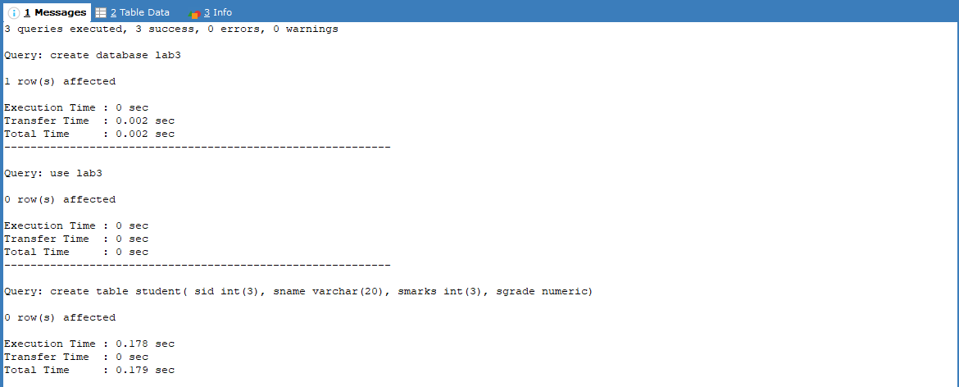

INSERT INTO student VALUES

(1,'Robot',72,7),

(2,'Richard',62,10),

(3,'Bob',92,12),

(4,'Tom',55,11),

(5,'Cameron',60,9),

(6,'Lily',59,12),

(7,'Sera',63,8);

SELECT \* FROM student;

